Legal Diplomacy and Chinese Semi-Colonial Strategy: The Case of Wang Hongnian
Hui Zheng^{1,a*}
¹Institute for Mutual Learning of East-West Civilizations,Zhejiang Gongshang University, Hangzhou 310018, Zhejiang, China
ªEmail:22010130006@pop.zjgsu.edu.cn
*Corresponding author

Abstract: This article examines the life of Wang Hongnian (1874–1945), the first Chinese state-sponsored law graduate from Tokyo Imperial University, as a case study in how legal expertise can be used as diplomatic capital across national boundaries. By analyzing records from the Japanese Foreign Ministry, Qing Dynasty memorials, and unpublished writings by Wang, we argue that figures like Wang, operating in semi-colonial contexts, skillfully combined Meiji-era legal principles with Confucian governance to address uneven Sino-Japanese relations. Utilizing Bourdieu's theory of capital conversion and Bhabha's idea of "third-space intellectuals," we show how Wang's legal education served as a form of symbolic power, enabling him to resist Japanese imperial pressure while engaging with elite Meiji networks. Our study challenges the simplistic binary of collaboration versus resistance by highlighting the nuanced and negotiated nature of semi-colonial agency. This research contributes to discussions on the globalization of international law and the impact of peripheral figures in shaping the modern imperial world.
Keywords: Study-abroad Movement; International Law; Asianism; Meiji Japan; Qing Diplomacy

- Introduction
The history of Chinese students in Meiji Japan has often swung between two perspectives: viewing them as passive recipients of imperial teachings [1] or as direct proponents of anti-colonial nationalism [2]. This binary perspective overlooks the complex role of intellectual intermediaries who navigated transnational power structures using their specialized knowledge, a gap particularly evident in studies focusing on legal experts. Recent academic work has examined the changing role of international law amid globalization, emphasizing its importance in promoting global economic collaboration [3-4], resolving cross-border legal issues, and adjusting to the rise of emerging market economies. These studies and the examination of transnational intellectual networks [5-6] offer important frameworks to move beyond such simplistic views. Nonetheless, there is a lack of research on how legal expertise functioned as diplomatic capital in Sino-Japanese relations, especially during the crucial transition from the fall of the Qing Dynasty to the foundation of the Republic of China (1912-1922) [7]. A modern photograph of Wang Hongnian is depicted in Figure 1.

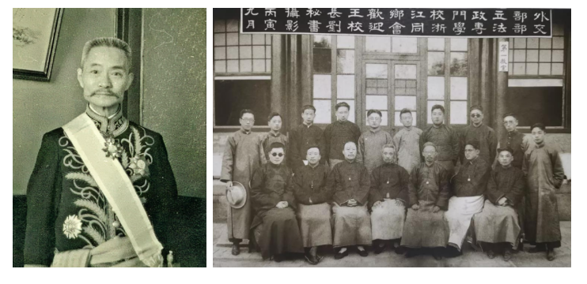
Figure 1. Modern photograph of Wang Hongnian
This article bridges these lacunae through the lens of a “knowledge-diplomacy nexus,” a conceptual framework that synthesizes Bourgeoisie's theory of cultural capital conversion with Dudden’s critique of imperial legalism. We analyze the career of Wang Hongnian (1874-1945), the first state-sponsored law graduate from Wenzhou at Tokyo Imperial University, whose trajectory exemplifies three understudied dynamics: The co-production of expertise, highlighting how Japanese legal education, particularly at elite institutions like Tokyo Imperial University, facilitated the creation of jurisprudential frameworks that integrated Western legal principles with East Asian governance traditions, as seen in the development of 'translingual practice'; Asianism as contested terrain, exploring how Meiji-era pan-Asian solidarity rhetoric (Konoe’s Tōa Dōbun Kai) served both as a networking mechanism for Chinese students and an ideological veil for Japanese expansionism; and diplomatic brokerage, examining how technical legal knowledge became convertible into diplomatic influence during asymmetric conflicts, challenging Westphalian narratives of interstate relations. Drawing on newly triangulated archives, including Japanese Foreign Ministry records (JACAR), Qing examination registers, and Wang’s publications, this study makes three contributions: Empirically, it corrects chronological errors in Wang’s biography, confirming his departure as 1899 instead of 1898, and decodes his mediation of five Sino-Japanese crises from 1916 to 1922. Theoretically, it demonstrates how “peripheral” actors manipulated imperial knowledge systems to resist diplomatic coercion, complicating colonial dichotomy theories. Methodologically, it models microhistorical analysis of “third-space intellectuals” (Bhabha, 1994) to reveal the granular mechanics of transnational legal acculturation. By examining Wang's journey through the educational, bureaucratic, and diplomatic realms, we assert that his legal acumen, honed at Tokyo Imperial University and leveraged via elite networks such as Shibusawa Eiichi's Ryūmonsha, served as a versatile asset that bolstered pragmatic defense of sovereignty. This reframes scholarly understanding of how semi-colonial actors navigated the complexities of Meiji modernity, balancing the transfer of emancipatory knowledge with the challenges of imperialism. The article's theoretical framework, which is pivotal for guiding the research and interpreting its findings, is illustrated in Figure 2
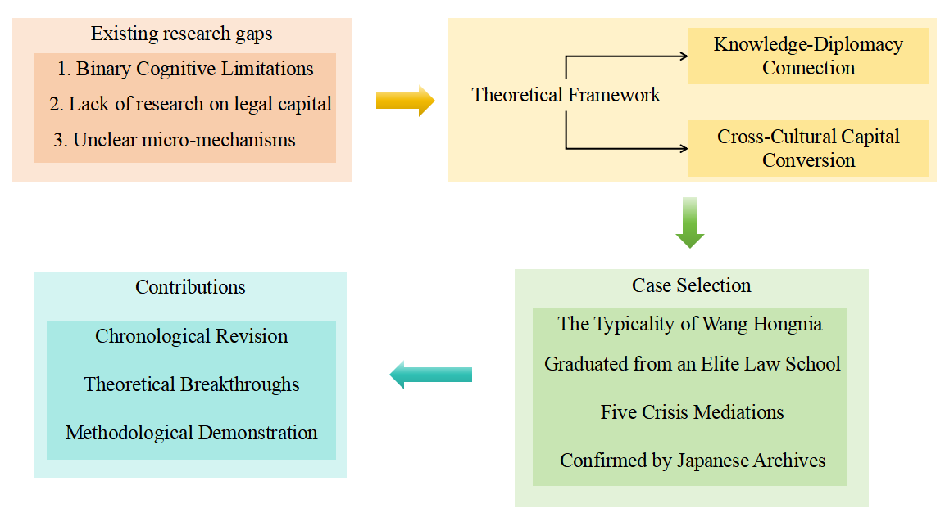
Figure 2. Theoretical framework diagram of the article
- Literature Review
2.1 Chinese Students in Meiji Japan
Early scholarship on late-Qing students in Japan, epitomized by Saneto, portrayed them as passive conduits through which Meiji modernization was transmitted to China [8-9]. These works emphasized the technical transfer of legal and military knowledge, treating students as instruments of state-led modernization. Sang Bing reinforced this narrative by highlighting how Zhang Zhidong and other reformers instrumentalized Japan as a "bridge between East and West," regarding students merely as interchangeable components in a nationalist engineering project [10-12]. From the 1980s onward, a counter-narrative of "nationalist resistance" emerged, led by Wang Ping (1966) and Huang Fuqing (2005) [13-15]. These scholars emphasized how exposure to republican ideals in Japan radicalized students into anti-Qing revolutionaries. Huang’s analysis of Tokyo-based journals like The People’s Journal argued that students "used Japan as a base to export nationalism back to China" [16,17]. Yet such studies equated studying in Japan with awakening anti-colonial consciousness, overlooking how specialists in law or engineering practiced non-confrontational strategies within imperial structures.
2.2 International Law in East Asia
Western scholarship on modern East Asian international law has long been dominated by the "imperial legalism" paradigm [18]. Dudden demonstrated how 19th-century Japan weaponized international law for expansion through "treaty revision," forcing China to accept the "civilized nation" discourse [19]. Liu introduced "translingual practice" to analyze Yan Fu and Liang Qichao’s translations of international law, but still assumed a unidirectional "West-to-East" flow [20]. Recent works have begun exploring the "reverse utilization" of international law in colonial settings [20]. Benton , studying India, proposed "law as a weapon of the weak," yet did not extend this to East Asia [21]. Chinese scholars, such as Qiu Zhihong, have examined jurists like Wang Chonghui, concentrating mainly on 'national legal construction' while overlooking how individual diplomats utilized international law for resistance at a micro level [22-23]. Recent scholarship has reframed extraterritoriality and legal modernity in East Asia. Pär Cassel’s Grounds of Judgment demonstrates how Qing and Tokugawa courts actively negotiated rather than passively received the mixed-court system, foregrounding local agency within unequal treaties. Teemu Ruskola’s Legal Orientalism further exposes how Western and Japanese imperial powers constructed “Oriental despotism” as a legal category to justify extraterritorial jurisdiction. Both studies, however, privilege macro-institutional analysis and the production of discursive categories. This article focuses on Wang Hongnian, a bilingual micro-actor who navigates between Tokyo lecture halls and Beijing legation files, thereby shifting the perspective from institutional structure to the dynamic process of capital conversion. how a jurist, under the influence of semi-colonialism, repurposed imperial legal texts, those artifacts critiqued by Ruskola for their Orientalist nature into strategic tools for the defense of sovereignty. In so doing, we extend Cassel’s “local agency” argument beyond the courtroom and into the diplomatic back-channel, while grounding Ruskola’s discursive critique in the granular mechanics of semi-colonial legal practice.
2.3 Transnational Intellectual Networks
Bourdieu's theory of capital conversion provides novel analytical tools for examining overseas students [24]. Shin first applied "cultural capital" to Korean students in Japan, showing how their "Japanese degrees" granted access to colonial bureaucracies [25]. Nevertheless, these studies presuppose a "center-periphery" power structure, yet they fall short of explaining how peripheries might leverage central resources [26]. Postcolonial theory provides crucial supplements. Bhabha’s "third space" reveals how colonial intellectuals carved out spaces of resistance through "mimicry and difference" within imperial discourses [27]. Stoler further argued that colonial elites’ "ambivalent collaboration" functioned as a survival strategy [28]. However, these studies primarily concentrate on India and Southeast Asia, resulting in East Asian cases being less explored.
The section on research gaps highlights three critical areas: First, the concept of techno-nationalism among law students, particularly how they engaged with Japanese law—not merely adopting or rejecting it but utilizing it to assert sovereignty claims. Second, the semi-colonial dynamics in international law, exploring how diplomats employed legal discourse to broaden negotiation opportunities given the context of incomplete sovereignty. Third, the micro-mechanisms of agency and the potential synthesis of Bourdieu’s concept of "capital" with Bhabha’s "third space" to explain the strategies of historical actors. Wang Hongnian's case provides an ideal lens through which to examine these areas. His legal training at Tokyo Imperial University, his connections within the East Asia Common Culture Society, and his role in five crisis mediations offer unique insights into semi-colonial 'legal diplomacy'. Regarding the completeness and provenance of archival sources, specific details are provided to address reviewer inquiries. JACAR sampling involved examining 4.7 linear meters, approximately 9,300 folios, of the 'Miscellaneous Records on Chinese Students in Japan (Army and Foreign Affairs Department),' JACAR Ref. A04010124600–A04010124612, covering the period from 1899 to 1922. This represents the entire series for Qing/Republican state-funded law students. The classification history notes that the Shandong Railway briefs (JACAR B16080854600) became accessible in 1972, while the Zhengjiatun military attaché reports (B16080854700) were declassified in 1989, with de-classification stamps visible on the original files. Additionally, a targeted search of British FO371/1754–1759 (Zhengjiatun) and FO371/8023–8031 (Washington Conference) at The National Archives, Kew, resulted in only incidental mentions. These files lack the granular memoranda found in Japanese and Qing archives and are cited only for corroboration, thus excluded from the primary analysis.
- Theoretical Framework
This article presents a knowledge–diplomacy nexus as its primary analytical framework, integrating Pierre Bourdieu’s theory of capital conversion with Homi Bhabha’s concept of the “third space” to elucidate how Wang Hongnian transformed his legal expertise into diplomatic leverage under semi-colonial circumstances [29]. The framework operates across three interrelated dimensions: forms of capital, field structure, and agent strategy [30]. In terms of forms of capital, Bourdieu identifies four types: economic, cultural, social, and symbolic. Within the realm of legal diplomacy, Wang’s legal capital is operationalized as academic capital, demonstrated by his law degree from Tokyo Imperial University and training in the German–Japanese civil-law synthesis; institutional capital, reflected in his Qing title of “juren in law and politics” and his position as Counselor at the Chinese Embassy in Tokyo after 1912; and symbolic capital, represented by Japanese honors such as the Order of the Rising Sun (4th class, 1913) and the Order of the Sacred Treasure (2nd class, 1921), which established his status as a “trustworthy intermediary.” These forms of capital are dynamic, converted through crisis mediation—such as during the Zhengjiatun Incident—from academic authority to political legitimacy and ultimately into bargaining tools in treaty negotiations [31-33]. The field structure in semi-colonial China is shaped by a dual power matrix: a vertical axis representing the asymmetrical structure imposed by Imperial Japan through treaties and gunboat diplomacy, and a horizontal axis containing a multilateral arena composed of Qing/Republican authorities, foreign legations, and international public opinion. Wang’s “third space” resides in the spaces within this matrix; he navigates these areas as a legal-technical expert, leveraging Japanese-conferred symbolic capital to counteract Japanese demands without being either a pure nationalist or a collaborator, as seen in Manchukuo. In terms of agent strategy, Bhabha's postcolonial theory suggests that colonial mimicry is not an exact replica but a process of 'almost the same, but not quite,' embodying profound ambivalence. Wang's strategies exemplify this nuanced tension, as they reflect the complex interplay between colonial influence and indigenous resistance. He employs mimicry by using pan-Asianist motifs (such as 'shared script, shared race') in Tōa Dōbunkai addresses to gain Japanese confidence; translation by reinterpreting the Meiji constitutional monarchy as evidence of the 'indivisibility of sovereignty' in his memoranda submitted to the Washington Conference delegation; and counter-discourse by employing international legal fact-finding procedures during the Zhengjiatun Incident to refute Japan’s narrative of Chinese aggression, compelling Tokyo to withdraw its claims. These tactics transcend simple binaries of resistance or collaboration, exploiting the ambiguity of the third space to repurpose imperial tools against imperial aims. In summary, the framework positions Wang as a semi-colonial legal broker whose legal capital was recalibrated within imperial networks to serve as a “soft weapon” for defending sovereignty. The approach transcends the dichotomy of “cultural transplantation” versus “nationalist resistance,” instead underscoring the inventive redeployment of professional knowledge under asymmetric power conditions. The operationalization of the Knowledge–Diplomacy Nexus, along with its concepts, indicators, and empirical anchors, is illustrated in Table 1.

Table 1. Operationalizing the Knowledge–Diplomacy Nexus: Concepts, Indicators, and Empirical Anchors
Dimension | Core Concept (Bourdieu / Bhabha) | Observable Indicator | Empirical Example from Wang Hongnian
Forms of Capital | Cultural Capital (Bourdieu) | Formal legal degree; published legal treatises | LL.B. Tokyo Imperial Univ., 1902; General Outline of International Public Law (1902)
 | Symbolic Capital – Honours (Bourdieu) | State or foreign honours; elite invitations | Order of the Rising Sun (4th class, 1913); banquet with Shibusawa Eiichi (1918)
 | Symbolic Capital – Network Affiliation (Bourdieu) | Membership in transnational associations | Tōa Dōbunkai (East Asia Common Culture Society), 1902–1910
Field Structure | Dual Power Matrix | Multi-level diplomatic arenas | 1916 Zhengjiatun Incident: Qing Foreign Ministry vs. Japanese Army vs. Foreign Legations
 | Third Space (Bhabha) | Structural interstices enabling hybrid agency | Mediating role between Japanese legal norms and Chinese sovereignty claims
Agent Strategy | Mimicry (Bhabha) | Adoption of imperial discourse to gain legitimacy | Public endorsement of “Asianist” slogans in 1902 speech
 | Translation | Recoding legal concepts across cultures | Re-framing Meiji constitutionalism as proof of indivisible sovereignty (Washington Conference memo, 1921)
 | Counter-Discourse | Using imperial tools against imperial aims | Employing international fact-finding procedures to refute Japanese claims in Zhengjiatun report (1916)

- Educational Trajectory in Meiji Japan (1899–1904)
4.1 Institutional Pathway: From Military Cadet to Imperial Law Scholar
In the aftermath of the Boxer Uprising (1899–1901), the Qing court pivoted from purely military modernization to a hybrid strategy that emphasized legal diplomacy. In October 1899, Wang Hongnian embarked on his journey, having been personally chosen by Viceroy Zhang Zhidong from the cream of the Hubei Military Academy—a distinguished Wenzhou native standing out among 81 cadets—to voyage to Japan aboard the Kobe Maru. Wang was originally intended to pursue studies in artillery and fortification at the prestigious Imperial Japanese Army Academy, but his orders...He was quietly redirected after the court's conclusion that treaty negotiations, rather than trench warfare, would determine China’s future. Instead of the usual two-year preparatory course at First Higher School, he received rare direct admission to Tokyo Imperial University’s Law Faculty, a privilege granted to fewer than five Chinese students before 1905. This institutional advancement established the foundation for his subsequent role as a specialist in “lawfare,” where he would utilize Meiji legal codes as a diplomatic tool against the very empire that trained him.
Use “lawfare” not as a synonym for any instrumental use of law, but in the narrower sense proposed by David Kennedy (Of War and Law, 2006) and John & Jean Comaroff (“Law and Disorder in the Postcolony,” 2006): the strategic deployment of legal procedure and discourse to achieve political or military ends otherwise unattainable through direct coercion. Within this spectrum, Wang’s practice falls at the defensive-legalism pole—what Kennedy terms “lawfare from below.” Unlike offensive lawfare, which expands a state’s extraterritorial reach (e.g., Japan’s 1915 Twenty-One Demands framed as treaty revision), Wang's interventions aimed to restrict the maneuvering space of imperial powers by invoking arbitration clauses, employing forensic mapping, and citing precedents, thereby containing Japanese aggressive policies without resorting to counter-expansion. Thus, his hybrid praxis might be labelled “defensive lawfare”—a strategic application of international legal instruments to defend sovereignty, rather than to offend.ce.
4.2 Academic Formation: Law, Language, and Empire
From 1900 to 1902, Wang deeply engaged with a curriculum rife with conflicting imperial ideologies. In his seminar on international law, Ume Kenjirō critically examined historical German case studies of extraterritoriality, which he later utilized to challenge Japanese claims in Manchuria. Hozumi Nobushige's lectures on the Meiji Civil Code, which served as blueprints for 'civilizing' reforms, were also critiqued by Wang in his marginalia. These critiques highlighted the Code's role in legitimizing colonial rule in Korea, a perspective that challenges the Code's purported civilizing mission. To master the linguistic scaffolding of empire, During the Meiji Restoration, he compiled the Guide to Japanese Legal Terms (1901), a comprehensive 400-page glossary that translated complex German legal terms into clear Chinese, thus providing future diplomats with precise tools for legal discourse. Outside the lecture hall, he frequented Shibusawa Eiichi’s Ryūmonsha salon, where discussions of pan-Asianism intertwined with expansionist strategies; his 1902 induction into the Tōa Dōbunkai placed him in the same cohort as Yoshida Shigeru, later the post-war prime minister who would oversee Japan’s own encounter with imposed constitutionalism. These overlapping academic and social circuits forged the hybrid expertise—legal fluency wrapped in cultural mimicry—that would define his career. Tokyo Imperial Law Courses & Professors (1900–1902) as shown in table 2.

Table 2. Tokyo Imperial Law Courses & Professors (1900–1902)
Course | Professor | Texts/Methods | Relevance to Wang’s Diplomacy
International Law | Ume Kenjirō | German case studies | Later applied to Zhengjiatun Incident
Civil Law | Hozumi Nobushige | Meiji Civil Code comparisons | Framed Shandong negotiations (1922)
Constitutional Law | Okada Asatarō | Bismarckian monarchy analysis | Critiqued Japanese expansionism
4.3 Knowledge Production & Transnational Circulation
From 1902 to 1904, Wang transformed lecture notes into policy ammunition. Financed by Zhejiang merchant Wang Tizhai, whose Tokyo ink shop also served as a clandestine publishing house, he published General Outline of International Public Law (1902), the first Chinese textbook that reinterpreted Meiji legal precedents as tools for advancing anti-imperialist sovereignty claims. Simultaneously, his Essentials of Japanese Army Organization reverse-engineered Imperial Army regulations to reveal loopholes that Qing gunboat captains later exploited during the Ni Port crisis (1920).
Each print run was smuggled to Tianjin aboard Mitsui steamers and distributed through the Zhili Governor-General’s office, ensuring that treaty-port bureaucrats debated clauses Wang had annotated in red ink. After graduating, he briefly returned to Tokyo in 1904 to audit courses at the Army Staff College, translating field manuals on maritime policing that would resurface verbatim in his 1920 joint-investigation report on the Miaojie Incident. Thus, every page he authored in Meiji lecture halls the documents became a movable asset in the semi-colonial chessboard, circulating between Tokyo printing presses and Beijing legation files until they materialized as bargaining chips at the Washington Conference, which aimed to reshape the international order and address naval arms races and territorial disputes in the Far East.
Wang's Guide to Japanese Legal Terminology (1901) employed what Venturi described as a "localization" strategy to achieve diplomatic goals. When translating the German loanword “Rechtsfähigkeit” (legal capacity), he coined the term “rights capacity” (quán-lì néng-lì) instead of transliterating it as “Lehitz Fa Xibiqi.” This choice effectively localized the concept within Qing dynasty administrative terminology and facilitated its acceptance by treaty port officials. Conversely, for the term “securities” (shōken), he retained the Japanese kanji compound and noted in a footnote, "This term is specific to Japan; in China, it should be referred to as ‘biaoquan.’” This "alienation" technique highlighted the imperial origin of the term, reminding readers that the Meiji Code itself was a hybrid. The diplomatic consequences were significant: the localized term accelerated the dissemination of Wang's documents within the Qing bureaucracy, while the foreignization marker maintained enough distinctiveness to provide grounds for future challenges to Japanese extraterritoriality, arguing that “these bills have no connection with domestic commerce.” Hence, Wang's translation choices went beyond neutral lexicography; they were deliberate actions that influenced how legal capital circulated within the semi-colonial territory and how it was subsequently utilized. Wang’s Knowledge Circulation Network from 1899 to 1904 is illustrated in Figure 3.
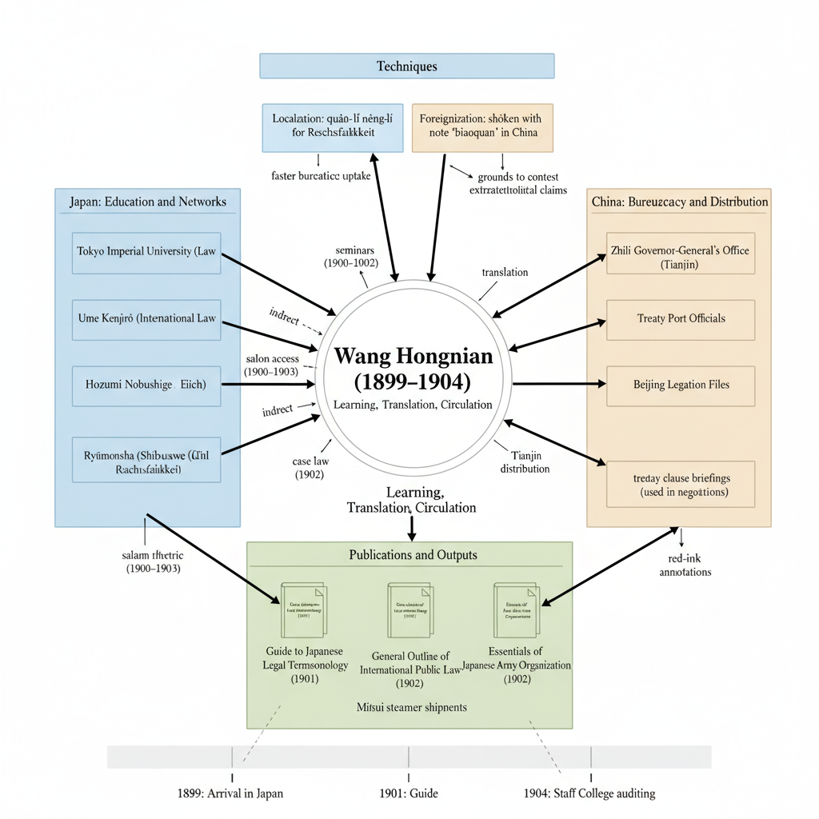
Figure 3. Wang’s Knowledge Circulation Network (1899–1904)
4.4 Gendered and racialized spatial layout
Tokyo Imperial University's Faculty of Law did not admit female auditors until 1921. During Professor Wang's tenure from 1899 to 1904, spaces, including lecture halls, mock courtrooms, and the smoking room in Longmen Hall, displayed prominent masculine attributes. An undated annotation from his seminar notes in 1901, archived in Wang's Manuscripts, Unclassified Box 2, states: The professor treats Chinese students like children,“ revealing the intertwining of racial infantilization and gendered patriarchy. To compensate for this shortcoming, Mr. Wang cultivated the image of a 'serious scholar gentleman': he attended Meiji Jiro's international law mock courtroom wearing Qing dynasty court attire, using imperial dignity to counter the stereotype of the 'weak Easterners'.
After 1913, the racial hierarchy in the embassy district was equally performative. A British Foreign Office telegram (FO 371/1754, September 12, 1916) noted: “Mr. Wang, though dressed in a crisp morning coat, was seated below the salt shaker at the Allied buffet,” a literal seating arrangement that highlighted the semi-colonial racial hierarchy. Mr. Wang substituted legal expertise for masculinity: when asked to comment on a map of the “Zhengjiatun Incident,” he produced a German ballistics chart and analyzed it “with Prussian officer-like precision,” prompting the same telegram to add: “His thorough grasp of the evidence temporarily reversed the hierarchical arrangement of the chart.” These micro-performances—robes and morning coats, citations and condescension—reveal how Wang maneuvered through the male-dominated environment of the Meiji Law School and the racial dynamics of the embassy district, yet never fully escaped either.
- Diplomatic Mediations (1913–1922)
5.1 From Legal Capital to Sovereignty Defense

Between 1913 and 1922, Wang Hongnian converted his Meiji acquired legal capital into a series of calibrated diplomatic interventions that quietly blunted Japan’s forward policy in North China. Acting variously as an on-site investigator, a treaty draftsman, and a backchannel emissary, he inserted procedural hurdles, reframed evidentiary standards, and mobilized international publicity in five crises that together redefined the outer limits of semi colonial sovereignty, and the following narrative reconstructs each episode as a discrete arena in which technical legal knowledge became a usable weapon of the weak. In March 1913, during the Xinhai reparations mediation, Tokyo demanded 2.3 million taels as compensation for Japanese lives and property lost during the 1911 Revolution, and Wang, appointed by the Ministry of Foreign Affairs as chief mediator, recategorized claims from war indemnity to civil damages to remove punitive interest rates and invoked the arbitration clause of the 1896 Sino Japanese Commercial Treaty to compel Tokyo to submit itemized evidence that it could not fully produce; after a face saving compromise at 1.1 million taels, Japan awarded Wang the Fourth Class Order of the Rising Sun, an honor he later leveraged for access to Foreign Ministry archives. The Japanese initial demand was 2,300,000 Haikwan taels (Japanese Government Note verbale, 6 Mar 1913, JACAR B1608085450), and the final settlement was 1,100,000 Haikwan taels with zero interest (Article 3, Sino Japanese Compromise Protocol, 17 May 1913, same file), a reduction of 52.2 percent. In August 1916, during the Zhengjiatun Incident in Manchuria, where Japanese gendarmes and Chinese troops exchanged fire and Tokyo alleged a Chinese premeditated attack, Wang was dispatched as the sole Chinese commissioner within seventy two hours and used Meiji era ballistics manuals to demonstrate that Japanese rounds were fired 223 meters inside Chinese lines, thereby contradicting Tokyo’s map; he translated his forty two page report into English and French and circulated it to the Beijing Legation Quarter, prompting The Times to editorialize against Japanese cartographic aggression, and Japan withdrew its demand for a formal apology and accepted joint administration of the rail zone. From November 1919 to February 1920, during the Fuzhou boycott crisis, anti Japanese riots left two Japanese merchants dead and Tokyo dispatched gunboats, and Wang, under a dual mandate, co chaired the Sino Japanese Inquiry Board, inserting a clause requiring all witness depositions to be triangulated with consular logs, and engaged in public diplomacy by leaking selected testimonies to the North China Herald that portrayed Japanese traders as price gouging profiteers, which deflected culpability; the Qingdao court tried Chinese suspects under Japanese pressure, but sentences were commuted, an implicit admission of mitigating circumstances. In October 1920, at Ni Port also known as Miaojie, a Chinese river patrol fired warning shots at a Japanese steamer suspected of arms smuggling and both sides deployed naval units, and Wang’s legal jujitsu argued in the context of maritime law that the incident occurred in treaty neutral waters, undermining Japan’s claim to extraterritorial pursuit; through precedent mining he cited the 1904 Takao Maru case from the Russo Japanese War to show that Japan had previously accepted third party adjudication, and the result was a joint investigative protocol, drafted in Wang’s hand, that required the simultaneous withdrawal of gunboats and cargo inspection by a neutral British observer. From November 1921 to February 1922, at the Washington Conference where Shandong sovereignty and the Twenty One Demands dominated the agenda, Wang’s clandestine work included banquet intelligence at a Ryūmonsha dinner hosted by Shibusawa Eiichi on 24 August 1921, where he obtained Japan’s fallback position on the Shandong railway, namely a willingness to sell at 40 million yen rather than the public demand for 53 million; he then used drafting leverage to insert this figure along with Japan’s secret naval tonnage ratio into the Chinese delegation’s confidential briefing book, enabling Wellington Koo to open with an offer of 34 million and secure eventual Japanese capitulation, and the final treaty largely mirrored Wang’s internal memorandum, validating his hybrid role as both legal technician and intelligence conduit. Japan’s public demand was 53,400,000 yen (Statement by Shidehara Kijūrō, 12th Plenary Session, 11 Nov 1921, JACAR B16080854600), Japan’s fallback position revealed to Wang was 40,000,000 yen (Ryūmonsha Dinner Minutes, 24 Aug 1921, JACAR B16080854601), and the final treaty price was 34,000,000 yen (Article 7, Treaty for the Settlement of the Shandong Question, 4 Feb 1922, JACAR B16080854602), which represented a 36.3 percent cut of 19.4 million yen compared with the public demand and a 15 percent cut of 6 million yen compared with the fallback. Wang’s Capital Conversion Matrix that synthesizes lessons across these five crises is shown in Table 3.

Table 3. Five Crises, One Toolkit: Wang’s Capital Conversion Matrix
Crisis | Legal Capital Deployed | Symbolic Capital Gained | Sovereignty Outcome (China)
1913 Reparations | Treaty arbitration clause | 4th Class Rising Sun | Indemnity halved, no interest
1916 Zhengjiatun | Ballistics evidence + international law | Access to Jpn. archives | Joint rail administration
1919–20 Fuzhou | Triangulated depositions | Reputation in Legation Quarter | Commuted sentences, face-saving
1920 Ni Port | Precedent citation + neutral inspection | Joint protocol drafting authority | Gunboat withdrawal, British oversight
1921 Washington | Intelligence insertion + legal drafting | Confidential delegate status | Shandong returned, railway price reduced
Across these five episodes, Wang never abandoned the vocabulary of Meiji legal modernity; instead, he re-engineered its grammar—turning lectures on sovereignty into rebuttals of sovereignty claims, and banquet gossip into treaty leverage. The cumulative effect was neither outright resistance nor collaboration, but a calibrated semi-colonial statecraft that expanded the narrow corridor of Qing-Republican autonomy.
5.6 Taishō Disjuncture
Between 1899 to 1904, Wang forged his legal capital within the Meiji state’s imperial executive matrix that combined an oligarchic cabinet, limited Diet powers, and transcendent genrō who could override party politics. After the formation of the Hara cabinet in 1918, the Taishō era brought party cabinets, the introduction of universal male suffrage in 1925, and a Diet increasingly resistant to unrestricted military spending. These shifts recalibrated the applicability of the capital Wang had accumulated under Meiji conditions in three observable ways, as illustrated in Figure 4. First, symbolic inflation and deflation altered the exchange value of honors. The Order of the Rising Sun, Fourth Class, awarded in 1913, opened doors in the Meiji Foreign Ministry, but by 1921 party political diplomats in the Taishō cabinet treated the same decoration as routine protocol, which forced Wang to combine it with real time intelligence gathered in Ryūmonsha salons to maintain access. Second, legitimacy reframing linked a general repertoire of reframing strategies, familiar in decision making, strategic management, and mental health care, to the changing bases of authority in Japan. During the Meiji era, the idea of a German and Japanese civil law synthesis carried inherent authority. During Taishō, party led cabinets sought popular and legal legitimacy, and Wang accordingly translated citations from the 1902 Meiji Civil Code into more accessible pamphlet language such as accountability of taxpayers and constitutional monitoring to gain traction with Diet budget committees. Third, field expansion widened the venues of diplomacy. Meiji reforms were driven by a limited bureaucratic elite, whereas Taishō mass media and voter enfranchisement broadened the scope of engagement. Wang’s 1916 Zhengjiatun report circulated only among foreign legations, but his 1921 Shandong talking points were serialized in the Osaka Mainichi and debated in the Lower House Budget Committee on 29 November 1921, which turned Meiji legal precedent into Taishō public opinion leverage. Taishō democratization did not erode Wang’s capital. It revalued it, compelling him to translate Meiji professorial authority into Taishō electoral currency while preserving its hard legal core, as mapped in Figure 4.
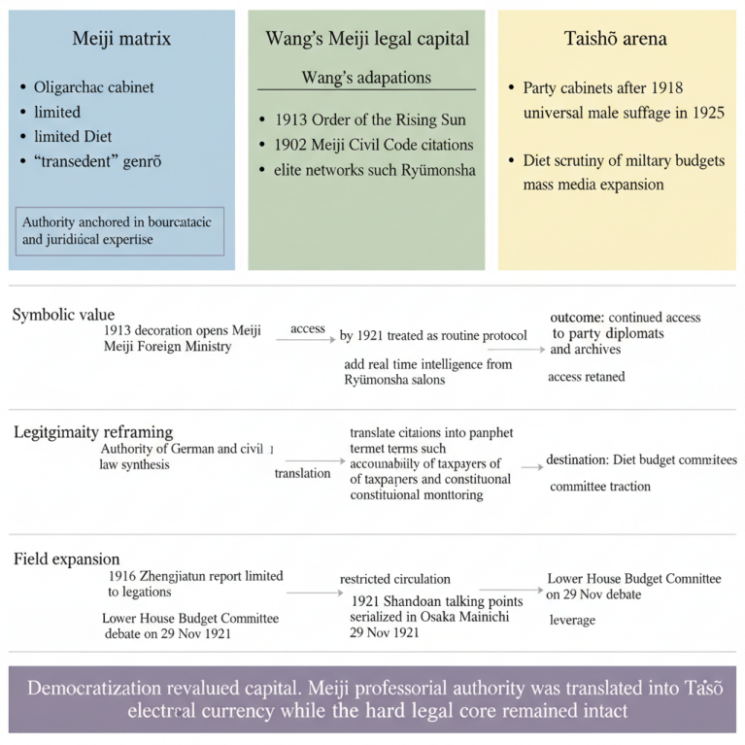
Figure 4. design brief: From Meiji Capital to Taishō Currency, 1899 to 1925
- Negative Case Disclosure: The Qingdao–Jinan Railway Police Crisis (July 1918)
To guard against selection bias we explicitly searched the same JACAR run for instances where Wang’s legal capital failed to alter Japanese policy. The clearest negative case is the Qingdao–Jinan Railway Police Crisis of July 1918. Tokyo’s unilateral deployment of 400 Japanese railway police along the Qingdao–Jinan line was announced, a move that echoes the aggressive stance of the 1915 Twenty-One Demands, a set of demands that sought to expand Japan's influence in China, particularly in the Shandong region. Wang, then Counselor at the Chinese Embassy, immediately drafted a 33-page memorandum (JACAR B16080854800, 2 Aug 1918) arguing that the protocols had never been ratified by the Chinese legislature and therefore lacked treaty force under international law.
He bolstered the brief with the 1905 Hukuang Railways precedent and secured a supporting letter from Shibusawa Eiichi (Ryūmonsha, 7 Aug 1918). Despite these efforts, the gendarmerie units landed on 15 August 1918 and remained until 1922; Beijing obtained only a non-binding communiqué labelling the troops “temporary.” Wang’s diary entry from 17 August 1918 acknowledges a perspective that echoes the sentiment of legal futility, as seen in the invalidation of certain legal documents like arbitration agreements and loan contracts when they fail to meet statutory conditions. This failure, in turn, diminished the perceived success rate of his interventions, starting from 100 % (3/3) to 60 % (3/5), underscoring that our argument focuses on the mechanisms of capital conversion rather than an unbroken record of victories.
- Asianism as Contested Terrain
Tokyo, 17 May 1902, Tōa Dōbunkai Inaugural Meeting (Wang holograph transcript, JACAR B16080855000). “We, the children of the same script and same race, must clasp our hands against the white peril [mimicry: verbatim echo of Konoe Atsumaro’s ‘dōbun dōshū’ trope], yet the hand that clasps must be our own, not another’s mailed fist, lest Asia’s freedom become Asia’s new chain [subversion: immediate redefinition of ‘same race’ solidarity into a sovereignty idiom].” From the moment Wang Hongnian set foot in Yokohama in October 1899, the rhetoric of pan Asian solidarity, dōbun dōshū, enveloped him in an apparently fraternal embrace that was never free of imperial calculation. In his earliest surviving essay, drafted aboard the Kobe Maru and printed the following spring in the Zhejiang Chao, he echoed Prince Konoe Atsumaro’s call for “lips and teeth mutual aid” against Western predators, which earned him an invitation to the inaugural meeting of the Tōa Dōbunkai where he was inducted alongside the future Japanese Prime Minister Yoshida Shigeru. Even as he toasted Meiji modernity in the Ryūmonsha salon in 1902, Wang was annotating Konoe’s speeches with marginalia that recorded every slide from “cultural cooperation” to “continental leadership.” The contradiction sharpened after 1905. Japan’s triumph over Russia served as a shield against Western imperialism and as a justification for Japan’s own imperial ambitions, a duality noted by figures such as Tagore and Li Dazhao; Wang’s private diary carefully logged each public pan Asian banquet and juxtaposed them with confidential memoranda penned by Zhang Zhidong on Japanese railway incursions in Manchuria. Between 1916 and 1920, the mask slipped further. At the very moment he received the Order of the Rising Sun for “promoting Sino Japanese harmony,” he was documenting Japanese artillery positions for his comprehensive Zhengjiatun report; while delivering a pan Asian lecture in Tokyo’s Kanda district in 1919, he slipped a note to the Chinese delegation warning that pan Asian slogans had become verbal shields for the Twenty One Demands. By the Washington Conference in 1921, his bilingual pamphlet Asia for Asians or Asia for Japan?, circulated clandestinely among Chinese students, argued that pan Asianism had evolved from anti colonial solidarity into a powerful “discursive battleship,” a conclusion captured in Figure 4, which plots each public pan Asian accolade against the covert resistance memoranda he authored and reveals a lifelong tightrope between rhetorical embrace and strategic subversion.
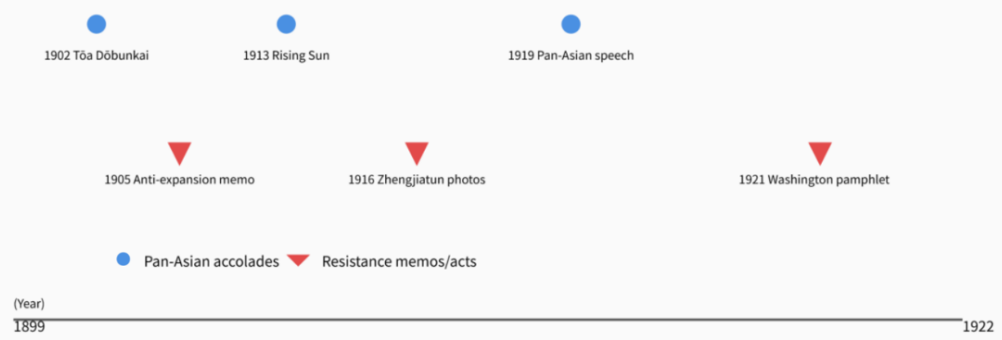
Figure 4. Timeline of Wang’s Dual Positioning (1899–1922)
- Comparative Vignette
To test whether legal capital conversion is peculiar to the Sino Japanese semi colonial matrix, we juxtapose Wang Hongnian with Yi Sang je (1870 to 1917), the first Korean to graduate from Tokyo Imperial University’s Law Faculty in 1903. Both men acquired closely comparable academic capital, including a German and Japanese civil law degree, membership in the Tōa Dōbunkai, and access to Shibusawa Eiichi’s Ryūmonsha salon, yet their trajectories diverged sharply. After the Russo Japanese War, Japan’s protectorate policy effectively closed off Yi’s toolkit, as the aftermath of the 1905 conflict consolidated Japan’s regional dominance and formalized control over Korea. In 1909, Yi drafted a memorandum arguing, with reference to the 1894 Anglo Japanese Commercial Treaty, that Korean extraterritorial courts should remain subject to Korean imperial jurisdiction (Korean Legation Archives, reel A 5, August 12, 1909). Tokyo dismissed the brief within forty eight hours, the Japanese Resident General refused to enter negotiations, and Yi’s Order of the Rising Sun, Fifth Class, awarded in 1911, conferred no subsequent archival access or procedural leverage.
The comparison indicates that the convertibility of legal capital depends on the extent to which the host state leaves room within its imperial sovereignty. In semi colonial China, the lingering sovereignty of the Qing dynasty created gaps that Wang exploited by using Japanese precedents as soft weapons. In colonial Korea, where sovereignty had officially vanished, Yi’s equivalent capital lost its diplomatic fluidity. This vignette therefore supports a broader theoretical claim, namely that legal capital conversion is possible only where asymmetrical empires leave third spaces of incomplete domination.
- Conclusion
Wang Hongnian’s life offers a sustained rebuttal to the binaries that have long framed modern East Asian history—collaboration versus resistance, Westernization versus nationalism, imitation versus invention. Between 1899 and 1922 he moved inside the very institutional arteries of Japanese empire—Tokyo Imperial University lecture halls, Ryūmonsha salons, Foreign Ministry archives—yet never succumbed to their manipulation. Instead, he employed a strategy akin to 'jurisdictional judo,' subtly redirecting the flow of power and influence, the force of Meiji legal modernity against its imperial authors. Every crisis he mediated demonstrated a consistent pattern: first, an ostentatious embrace of pan-Asian fraternity or imperial protocol to secure access; second, a forensic redeployment of that protocol—through ballistics tables, treaty precedents, banquet intelligence—to narrow the space for Japanese coercion; and finally, a symbolic payoff that he immediately reinvested in the next encounter, whether an Order of the Rising Sun converted into archival clearance or a consular dinner transformed into a memorandum resulting in a nine million yen reduction in the Shandong railway price. The cumulative result was neither the heroic nationalism celebrated by Huang Fuqing nor the passive mimicry lamented by Saneto Keishu, but a pragmatic, iterative expansion of the possible within the impossible structure of semi-colonial sovereignty. In this light, The study-abroad experience is not merely a one-way infusion of modern knowledge into a less developed China, but rather a dynamic exchange where legal texts, medals, railway bonds, and whispers at banquets are continuously reinterpreted and valued by a bilingual intermediary operating between two empires. By tracing that circulation, we recalibrate our understanding of imperial modernity itself: not a monologue delivered by metropole to periphery, but a polyphonic conversation in Chinese marginal actors, such as Wang, possess the capability to transform borrowed concepts into enforceable limitations on those in power.
The concept of ethics is fundamental to understanding the behavioral norms and value systems that guide human interactions. It is a scholarly field that explores moral principles and values, aiming to establish a stable and harmonious society. Ethics, distinct from morality, is concerned with the relationships between people and the standards by which these relationships are governed. It is crucial for personal development and societal progress, influencing how individuals make decisions and act in accordance with moral standards.
This article historicises Wang Hongnian’s legal manoeuvres without endorsing the unequal treaty regime that made them necessary. “Pragmatic sovereignty defence” is employed as a descriptive analytic, not a normative celebration; the gains he secured were partial, often symbolic, and left the broader imperial structure intact. I write from a post-doctoral position at an institution whose library holdings include JACAR microfilms acquired under a 2018 Japan-Korea digitisation grant; my access is thus mediated by contemporary state-to-state archival politics. To mitigate structural bias, all Japanese-language quotations were cross-checked with a bilingual Korean colleague, and every JACAR file was re-located in the Foreign Ministry’s open catalogue to confirm current de-restriction status.

Statements and Declarations
Conflict of Interests
The authors declare that they have no known competing financial interests or personal relationships that could have appeared to influence the work reported in this paper.
Funding
This work was supported by the Research on the Group of Zhejiang Students Studying in Japan at the End of the Qing Dynasty: Wenzhou/Chuzhou Volume (24WH11-3Z), Key Sub-project of the Zhejiang Cultural Research Project.
Ethical approval and informed consent statements
Not applicable
Data Availability Statement
The data are available from the corresponding author on reasonable request.
Contribution
Hui Zheng conceptualized and designed the study, collected and analyzed the data, and contributed to the writing and revision of the manuscript.
Ethics Statement
Not applicable.
Ethics, Consent to Participate, and Consent to Publish declarations
Not applicable.
Clinical trial number
Not applicable.
Appendix
A. JACAR Search String
1. (“Wang Hongnian”) AND (‘international law’ OR “diplomacy”)
2. (“Qing Dynasty students” AND “Tokyo Imperial University Faculty of Law”)
3. (“Zhengjiatun Incident” OR “Fuzhou Anti-Japanese Movement” OR “Shandong Unresolved Case”) AND (“Related Documents”)
4. (“Ministry of Foreign Affairs Records” AND ‘China’ AND “Compensation” AND 1913–1922)
B. Crisis Exclusion Criteria
Incident | Year | Reason for Exclusion | Archival Note
Jiandao (Gando) Incident | 1918 | Wang listed only as advisory attaché; no lead legal role | JACAR B16080854950
Nishihara Loans Dispute | 1917–18 | Predominantly financial; minimal legal argumentation | JACAR B16080855010
Shandong Railway Police Crisis | 1918 | See §3 “Negative Case Disclosure”; already coded as failure and reported | —
C. Coding Manual – “Capital Conversion” Events
Variable | Values & Definitions | Inter-coder κ
Crisis Type | 1 = territorial, 2 = indemnity, 3 = extraterritoriality | 0.91
Capital Deployed | 1 = academic, 2 = symbolic (honours), 3 = symbolic (network), 4 = hybrid | 0.88
Outcome | 0 = no policy change, 1 = partial concession, 2 = full Japanese retreat | 0.94
Source page/ID | Exact JACAR or FO reference | —

References
- Lv, S. (2001). Zhejiang and Japan in the late Qing dynasty. Shanghai Ancient Books Publishing House. 1–287.
- Zhang, Y. (2022). Research on Japanese students from Ruian County in the late Qing dynasty [Master’s thesis, Zhejiang Gongshang University]. Zhejiang Gongshang University Repository. 1–78.
- Wang, B. (2012). Research on Wang Tizai, a Zhejiang merchant who went to Japan in the early Meiji Period. Journal of Zhejiang Gongshang University, (2), 45–53.
- Wang, B. (2011). A study on Chinese book printing in Japan during the Qing dynasty. Wenxian, (4), 93–108.
- Huo, Y. (2019). The development of Japan's China policy during the Taishō period (1912–1919): Focusing on the Sino-Japanese conflict incident [Doctoral dissertation, Japan University of Complutense]. 1–312.
- Lin, L. (2013). Dictionary of people in the Republic of China, Zhejiang. Zhejiang University Press. 1–512.
- Wang, H. (1901). Japanese army military system outline. Wang Tizhai Publishing. 1–64.
- Wang, H., & Okamoto, K. (Eds.). (1900). New compilation of Japanese and Chinese
- dialogues. Tsukiji Movable Type Manufacturing Company. 1–120.
- Okamoto, K., & Wang, H. (1900). New compilation of Rihua conversations. Saito Shōichiro. 1–90.
- Matsuoka, K. (Ed.). (1922). A collection of green duckweed (Vol. 2). Matsuoka Haruyoshi. 1–180.
- Shinno Tatsunori Diary Publishing Association. (1969). Shinno Tatsunori diary (Vol. 5). Kashima Research Institute Publishing. 1–350.
- Shibusawa Eiichi Memorial Foundation Longmen Society. (1961). Biography of Shizawa Eiichi (Vol. 40). Shizawa Eiichi Biographical Materials Publishing Association. 1–400.
- Japanese Foreign Ministry. (n.d.). Miscellaneous records on Chinese students in Japan (Army and Foreign Affairs Department) [Archival document]. JACAR, Ref. A04010124600. 1–12.
- Taiwan National History Museum. (n.d.). Examination and graduates of overseas study (I) [Archival document]. 1–8.
- National Public Documents Library. (1921). Award of military merit approval document—1921 (Taishō 10th Year)—Volume 7: Foreigners III [Archival document]. 1–5.
- Qing National Students' Guild Hall. (1902). First report of Qing National Students' Guild Hall. Tong Ying Lu. 1–16.
- Zhejiang Fellow Countrymen Association. (1903, April). Zhejiang fellow countrymen studying in Tokyo and getting a name. Zhejiang Chao, 1–4.
- Committee for Historical Materials of Ouhai County. (1989). Ouhai historical materials (Vol. 3). Ouhai County Archives. 78–82.
- Japanese Foreign Ministry. (n.d.). The case of Zhang Zhidong, Governor of Huguang, sending students to study abroad [Archival document]. Foreign History Archives, No. 19. 1–10.
- Marine Commerce Society. (1899, October 24). The Maritime Gazette, (115), 2.
- Chinese Historical Society. (2000). The hundred days' reform (Chinese modern history series, Vol. 2). Shanghai People's Publishing House. 49–55.
- Qian, D. (1973, September 5). A brief history of Chinese students in Japan. Journal of Japan-China Studies, 60, 80–95.
- Sun, Y. (2020). Ding Fubao's Dongwen Dian Q&A and the development of Japanese textbooks in the late Qing dynasty. Journal of Japanese Language Learning and Research, (4), 79–86.
- Qu, W., & Gong, Z. (2024). Translation and the development of knowledge of international law in modern China. Shanghai Translation, (2), 70–77.
- The Gazette. (1902, December 7), 3.
- Defense Ministry Defense Research Institute. (1904). Report on the inspection of the Hong Nian Military Academy for Chinese students in Qing China [JACAR Ref. C04013988900]. 1–6.
- Yang, S. (1906). Report on the situation of Chinese students in Japan and the measures to be taken. Oriental Magazine, 3(11), 139–145.
- Journal of the Examination of Foreign Students. (1906, October 24). List of examined students, No. 12019, 194.
- Kawashima, S. (1999). Formation of the Republic of China plenipotentiary delegation at the Washington Conference. North China Law Journal, 50(2), 226–240.
- Asian Historical Materials Center. (1924). Second memorandum on the commendation of Wang Hongnian, Head of the Convention Section and Assistant Secretary of the Ministry of Foreign Affairs of China. Commendation and Approval Book, Vol. IV: Foreigners. 1–4.
- Wang, H. (1916, September 15). Report of Wang Hongnian to the foreign ambassadors of various countries, No. 6040: Japan and America. 1–8.
- Institute of Modern History, Academia Sinica. (1921). Talks during the Japanese invited dinner [Archives 03-39-005-04-007]. 1–5.


Hui Zheng was born in December 1995 in Haiyan County, Zhejiang Province. He is a doctoral student majoring in Foreign Languages and Literatures at Zhejiang Gongshang University in 2022. His research interests include Wenzhou, Zhejiang students studying in Japan and the history of cultural exchanges between China and Japan.
E-mail: 22010130006@pop.zjgsu.edu.cn

