Gender Differences in the Changes of Physical Fitness Indicators Across Academic Years Among Undergraduate Students: A Longitudinal Data Analysis

Nianting Liu^{1+,}*, Renyi Ding¹

1 Zhejiang Police College, No. 555 Binwen Road, Binjiang District, Hangzhou, Zhejiang 310053, China
* Corresponding Author: Nianting Liu, Email: lhyj2008@qq.com

Abstract
Objective: To examine grade-related changes in physical fitness indicators among undergraduate students and to explore sex differences in these trajectories, providing empirical evidence for physical education programs in universities.
Methods: Longitudinal data from undergraduate physical fitness tests conducted at a university between 2013 and 2025 were analyzed. Lung capacity, standing long jump, sit-and-reach, and the 50-m sprint were included as outcome variables. Linear mixed-effects models were applied to lung capacity, standing long jump, and sit-and-reach to account for repeated measurements within individuals. For the 50-m sprint, performance was converted to running speed (m/s) and analyzed using generalized estimating equations. Grade, sex, and their interaction were included as fixed effects, with enrollment year and gap years as covariates.
Results: A total of 14,920 students with 49,156 observations were included. Lung capacity and standing long jump performance increased significantly with grade (P<0.001), and males exhibited higher levels than females for these indicators (P<0.001). Significant grade-by-sex interactions were observed for both lung capacity and standing long jump (P<0.01), indicating smaller grade-related improvements among females. Enrollment year showed significant associations with several fitness indicators. Results for 50-m running speed were consistent with these main patterns and robust across different data-cleaning strategies.
Conclusion: Physical fitness indicators among undergraduate students demonstrate clear grade-related changes and pronounced sex differences. Findings from this longitudinal analysis provide empirical support for understanding physical fitness development in undergraduate populations and may inform physical education practices in universities.
Keywords: undergraduate students; physical fitness indicators; grade; sex differences; longitudinal analysis

In recent years, the Chinese government has attached great importance to the issue of student physical health. The Outline of the Plan for Building a Leading Country in Education (2024–2035) clearly proposes deepening the reform of school physical education and promoting the all-round development of students. In addition, the Opinions on Implementing the Student Physical Fitness Enhancement Program, jointly issued by five ministries including the Ministry of Education, further provides systematic arrangements for strengthening students’ physical health, offering clear policy guidance for school physical education and student fitness development [1][2]. Against this background, the changing patterns of physical fitness among undergraduate students and their influencing factors have become important research topics in higher education.
Existing studies have shown that the overall physical health level of Chinese university students has exhibited either a declining or fluctuating trend, and that students in different academic years differ in various physical fitness indicators [3][4]. Related research has also found that university students’ physical fitness levels have shown marked changes across different historical periods, with prominent gender differences [5][6]. However, most existing studies are based on cross-sectional data, making it difficult to accurately characterize individual developmental trajectories of physical fitness across academic years during undergraduate study, and also difficult to reveal gender-specific patterns of change. Therefore, a systematic analysis of gender differences in the changes of physical fitness indicators across academic years among undergraduate students based on longitudinal data is of important practical significance for deepening the reform of university physical education and implementing policies related to student physical fitness enhancement.

1 Study Subjects
The study population consisted of full-time undergraduate students enrolled at a university in China. The data were obtained from the university’s annual physical fitness test records and corresponding student registration information from 2013 to 2025. Because the standard undergraduate training period in Chinese universities is four years, the data for each year generally included students from multiple enrollment cohorts. For example, the 2013 dataset included students enrolled from the 2010 to 2013 cohorts; the 2018 dataset included students from the 2015 to 2018 cohorts; and the 2025 dataset included students from the 2022 to 2025 cohorts.
Using student ID numbers as unique individual identifiers, repeated measurements from the same student across different academic years were longitudinally matched to construct an individual-level longitudinal database. All participants were full-time undergraduate students; junior college students and postgraduate students were excluded. A total of 14,920 students were ultimately included, yielding 49,156 valid observation records. The relevant physical fitness test indicators and implementation procedures were all conducted in accordance with the National Student Physical Health Standards [7].

2 Methods

2.1 Indicator and Variable Processing
This study selected vital capacity, standing long jump, sit-and-reach, and 50 m sprint from the student physical fitness test as indicators of physical fitness. Among them, vital capacity (mL) reflects cardiopulmonary function, standing long jump (cm) reflects lower-limb explosive power, sit-and-reach (cm) reflects flexibility, and the 50 m sprint is used to assess short-distance speed ability.
The variable academic year was defined as the student’s year of study at the time of testing and was coded from 1 to 4, corresponding to freshman through senior year. To facilitate model estimation and interpretation of interaction effects, the academic year variable was centered (grade_center), that is, expressed as the deviation from the sample mean academic year. Gender was coded as male = 0 and female = 1.
At the same time, year of enrollment (cohort year) and years of suspension (gap year) were included as covariates to control for the potential effects of differences in enrollment period background and discontinuous study experience on physical fitness indicators. The year of enrollment variable was also centered in the analysis (cohort_center) to reduce multicollinearity and improve model stability.
For the 50 m sprint, considering that it is measured in time (s) and its numerical distribution is skewed, the sprint result was converted into a speed indicator (m/s) for easier interpretation and better model fitting, calculated as 50 m divided by completion time. A higher speed value indicates better sprint performance. The GEE results for 50 m sprint speed are presented in Supplementary Table S2. The main effects were consistent in direction under both Rule A (no filtering of extreme values) and Rule B (filtering based on the 1st–99th percentile range of speed), indicating robust results.

2.2 Statistical Analysis
This study employed longitudinal data analysis methods to examine gender differences in the changes of physical fitness indicators across academic years among undergraduate students. Given that repeated measurements were available for the same student across different academic years and the observations were therefore not independent, linear mixed-effects models (LMMs) were used to analyze vital capacity, standing long jump, and sit-and-reach [8][9][10]. Student-level random effects were specified with random intercepts to account for inter-individual differences. The fixed effects included academic year (grade_center), gender, the academic year × gender interaction, and the covariates year of enrollment (cohort_center) and years of suspension (gap_year).
To test the necessity of including the interaction between academic year and gender, a baseline model without the interaction term and a model including the interaction term were constructed and compared using maximum likelihood (ML) estimation. Final parameter estimates were then obtained using restricted maximum likelihood (REML). Model results were reported as regression coefficients (β), standard errors (SE), z values, P values, and 95% confidence intervals (95% CIs).
For the 50 m sprint, because the converted speed data still had a repeated-measures structure, generalized estimating equations (GEEs) were used for analysis [10][11]. Students were treated as the clustering unit, and an exchangeable working correlation structure was assumed to obtain robust parameter estimates. To test the robustness of the findings, analyses were conducted both on the unfiltered sample and on the sample filtered by percentile thresholds, and the direction and significance of the main effects were compared across the two datasets.
All statistical analyses were performed in the Python statistical environment, mainly using the statsmodels package. All significance tests were two-sided, and the level of statistical significance was set at P < 0.05. Linear mixed-effects models and generalized estimating equations are classical methods for handling repeated-measures data in longitudinal analyses, and their theoretical foundations and inferential frameworks have been systematically described in the methodological literature.

3 Results

3.1 Effects of Academic Year, Gender, and Their Interaction on Vital Capacity
The results of the linear mixed-effects model showed that academic year had a significant positive effect on vital capacity among undergraduate students (β = 27.86, P < 0.001), indicating that students’ vital capacity generally increased with advancing academic year. The main effect of gender was also significant (β = −1323.25, P < 0.001), suggesting that male students had significantly higher vital capacity than female students.
The academic year × gender interaction was statistically significant (β = −11.85, P = 0.008), indicating that the pattern of change in vital capacity across academic years differed by gender. Further analysis showed that the increase in vital capacity with academic year was greater in male students than in female students, implying that the academic-year gain in vital capacity during the undergraduate period was relatively limited among female students.
After controlling for year of enrollment and years of suspension, the above results remained stable. Year of enrollment had a significant negative effect on vital capacity (β = −41.63, P < 0.001), and the effect of years of suspension was also statistically significant (β = −152.40, P < 0.01). The detailed parameter estimates of the model are presented in Table 1. The predicted means of vital capacity and their 95% confidence intervals across academic years and gender groups are shown in Figure 1.
Table 1. Results of the Linear Mixed-Effects Model (REML) for Vital Capacity in Relation to Academic Year, Gender, and Their Interaction
Variables | β (Coef.) | SE (Std.Err.) | z | p | 95%CI
Intercept | 88355.441 | 2175.183 | 40.620 | <0.001 | [84092.160, 92618.721]
Grade (centered) | 27.856 | 1.805 | 15.435 | <0.001 | [24.319, 31.393]
Sex (Female=1) | -1323.245 | 12.591 | -105.097 | <0.001 | [-1347.923, -1298.568]
Grade × Sex | -11.854 | 4.448 | -2.665 | 0.008 | [-20.572, -3.136]
Enrollment Year | -41.625 | 1.078 | -38.618 | <0.001 | [-43.737, -39.512]
Years of Suspension | -152.404 | 39.279 | -3.880 | <0.001 | [-229.390, -75.419]
Note: The dependent variable was vital capacity (mL). Academic year was coded as freshman = 1, sophomore = 2, junior = 3, and senior = 4, and was centered at the sample mean (mean = 2.448). The model was a linear mixed-effects model (REML) with student-specific random intercepts; number of observations = 49,156 and number of students = 14,920.
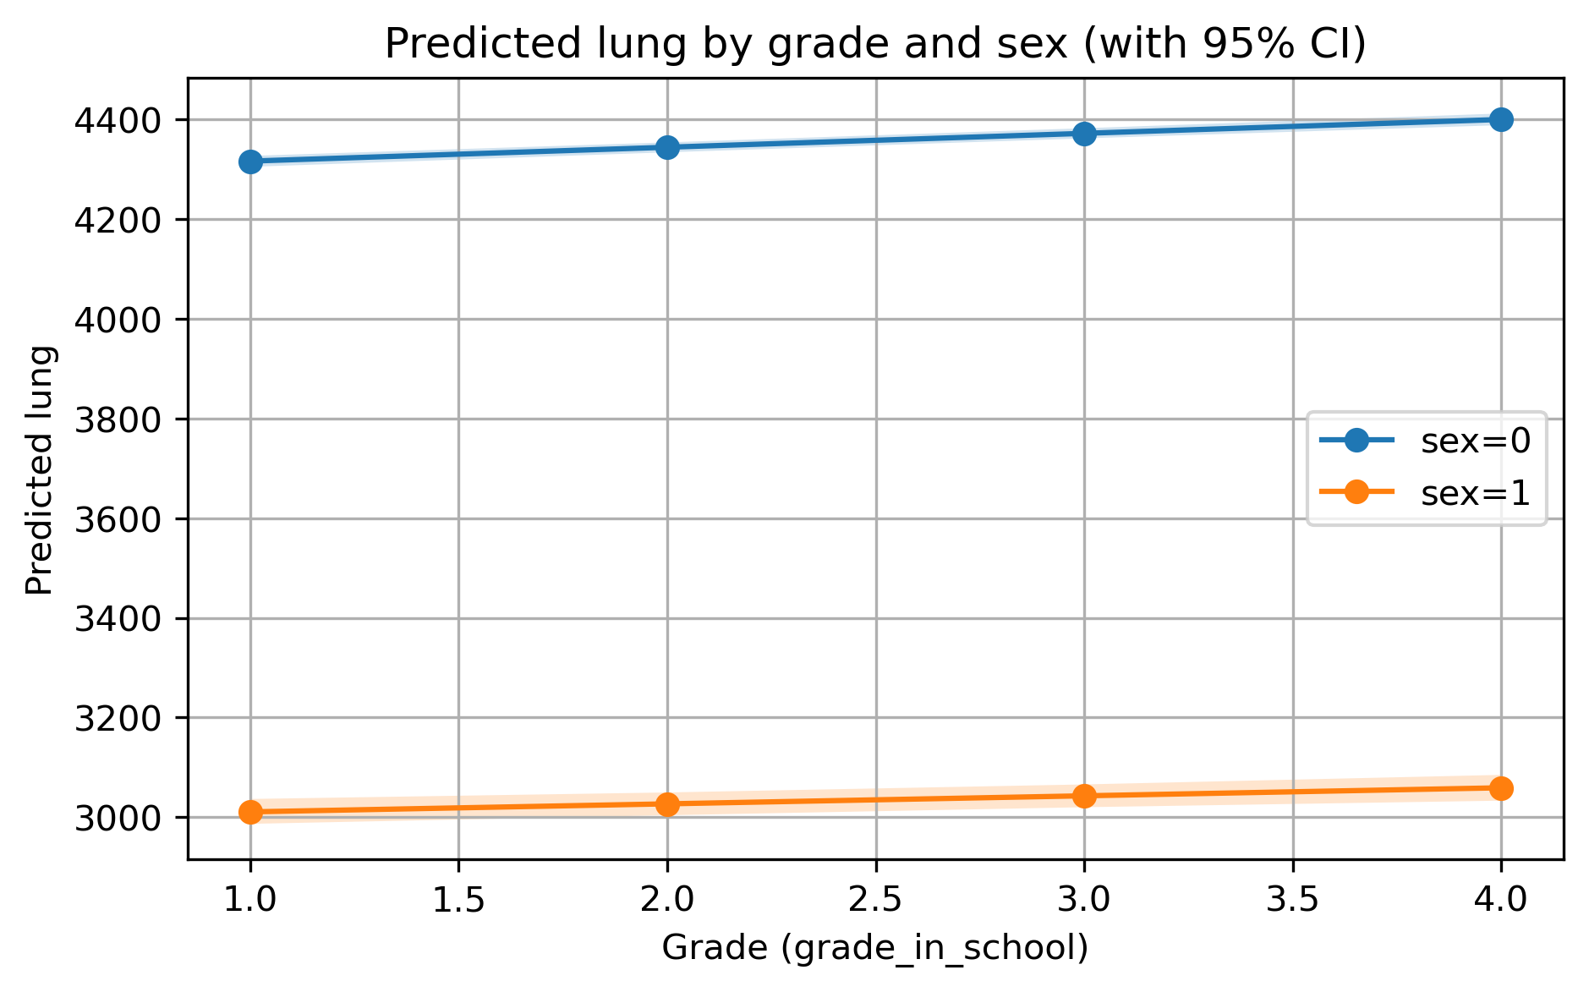
Figure 1. Gender Differences in Vital Capacity Among Undergraduate Students Across Academic Years (95% Confidence Intervals)
Note: Predicted means and 95% confidence intervals were derived from the linear mixed-effects model, controlling for year of enrollment and years of suspension.

3.2 Effects of Academic Year, Gender, and Their Interaction on Standing Long Jump Performance
The results of the linear mixed-effects model showed that academic year had a significant positive effect on standing long jump performance among undergraduate students (P < 0.001), indicating that students’ lower-limb explosive power generally improved with advancing academic year. The main effect of gender was also significant (P < 0.001), with male students demonstrating overall better standing long jump performance than female students.
The academic year × gender interaction reached statistical significance (P < 0.05), suggesting that the pattern of change in standing long jump performance across academic years differed by gender. Specifically, the increase in standing long jump performance with academic year was greater in male students than in female students, indicating that the improvement in lower-limb explosive power during the undergraduate period was relatively limited among female students.
After controlling for year of enrollment and years of suspension, the above results remained stable. The detailed parameter estimates of the model are shown in Table 2, and the trend of gender differences in standing long jump performance across academic years is presented in Figure 2.
Table 2. Results of the Linear Mixed-Effects Model (REML) for Standing Long Jump Performance in Relation to Academic Year, Gender, and Their Interaction
Variables | β (Coef.) | SE (Std.Err.) | z | p | 95%CI
Grade (centered) | -36.857 | 58.621 | -0.629 | 0.530 | [-151.753, 78.039]
Sex (Female=1) | 2.509 | 0.053 | 47.084 | <0.001 | [2.405, 2.614]
Grade × Sex | -50.445 | 0.337 | -149.875 | <0.001 | [-51.105, -49.786]
Enrollment Year | -1.517 | 0.131 | -11.564 | <0.001 | [-1.774, -1.260]
Years of Suspension | 0.139 | 0.029 | 4.771 | <0.001 | [0.082, 0.196]
Grade (centered) | -2.217 | 1.110 | -1.997 | 0.046 | [-4.392, -0.041]
Note: The dependent variable was standing long jump (jump). Academic year was coded as freshman = 1, sophomore = 2, junior = 3, and senior = 4, and was centered at the sample mean (mean = 2.448). Gender was coded as male = 0 and female = 1. The model was a linear mixed-effects model (REML) with student-specific random intercepts; number of observations = 49,156 and number of students = 14,920.

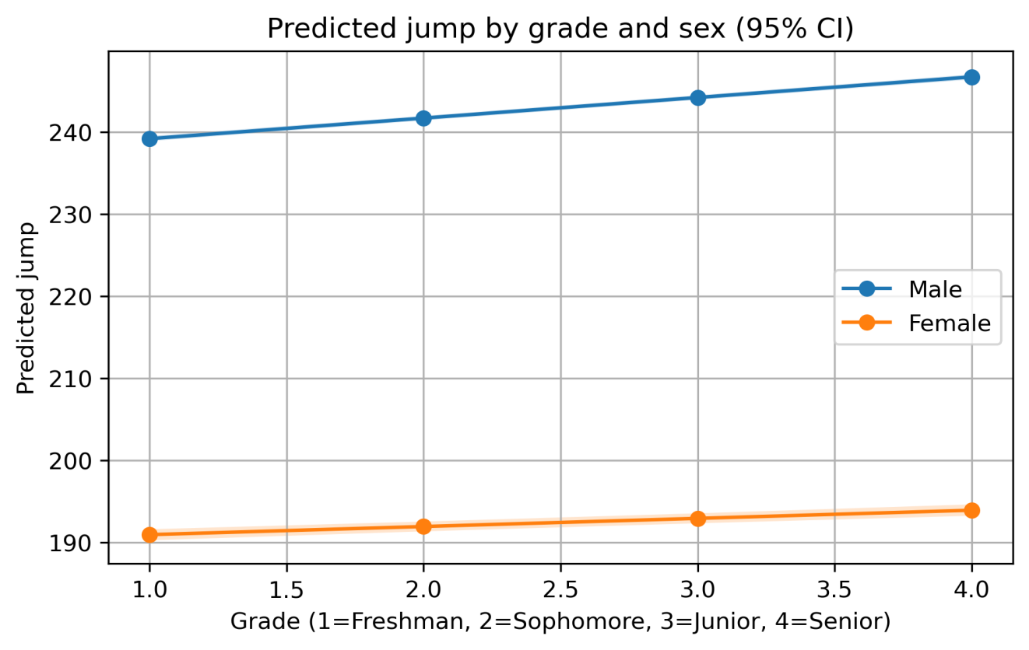
Figure 2. Gender Differences in Standing Long Jump Performance Among Undergraduate Students Across Academic Years (95% Confidence Intervals)
Note: Predicted means and 95% confidence intervals were derived from the linear mixed-effects model, controlling for year of enrollment and years of suspension. The analysis results for sit-and-reach and 50 m sprint are presented in the Supplementary Tables.

4 Discussion

4.1 Overall Patterns of Physical Fitness Changes Across Academic Years During Undergraduate Study
Based on longitudinal data, this study systematically examined the patterns of change in physical fitness indicators across academic years among undergraduate students. The results showed that both vital capacity and standing long jump performance improved significantly with advancing academic year. This finding suggests that students’ physical fitness levels are not static during the undergraduate period, but rather retain a certain degree of developmental potential [12].
Most previous studies have compared physical fitness levels among students in different academic years using cross-sectional data. Although such studies can, to some extent, reflect differences between academic years, they are limited in accurately characterizing individual developmental trajectories of physical fitness over time. In contrast, by longitudinally matching repeated measurements from the same students across multiple academic years, the present study more directly captured the actual trend of physical fitness changes during undergraduate study, thereby providing more robust evidence for the conclusions drawn.
From a practical perspective, these findings suggest that there remains considerable room for the implementation of physical education teaching and fitness intervention measures during the undergraduate period. Appropriate curriculum design and exercise guidance may help promote the continuous development of students’ physical fitness.

4.2 Possible Mechanisms Underlying Gender Differences in Physical Fitness Changes
The results showed that the academic year × gender interaction was statistically significant for both vital capacity and standing long jump, indicating that the patterns of change in physical fitness across academic years differed by gender. Specifically, the magnitude of improvement in physical fitness indicators across academic years was generally greater in male students than in female students, while the academic-year gain in physical fitness among female students was relatively limited during the undergraduate period.
This difference may be jointly associated with behavioral and physiological factors. From a behavioral perspective, previous studies have shown that female students generally participate in lower levels of physical activity, with lower exercise frequency and intensity than male students during university, and that their enthusiasm for sports participation tends to decline more markedly with advancing academic year [13][14][15]. From a physiological perspective, males and females differ in muscle strength, baseline cardiopulmonary function, and growth, development, and adaptability, and these differences may influence how physical fitness indicators change across academic years [16][17].
It should be noted that the above explanations are mainly based on reasonable inferences drawn from previous studies and the observed results, and therefore cannot support causal conclusions. Future research should incorporate information on physical activity level, course participation, and training load to further explore the mechanisms through which different behavioral factors contribute to the formation of gender differences.

4.3 Cohort Effects and the Influence of Historical Context
The results of this study showed that, after controlling for academic year and gender, year of enrollment still had a significant effect on some physical fitness indicators, suggesting that changes in undergraduate students’ physical fitness may be shaped not only by individual developmental factors but also by broader historical and contextual influences [18]. Students from different enrollment cohorts may differ in terms of growth environment, learning style, and lifestyle, and these differences may, to some extent, affect their physical fitness development.
In recent years, with the increasing informatization of learning methods and the rise in sedentary behavior, students’ overall levels of physical activity have shown a declining trend. Previous studies have pointed out that students from different periods differ significantly in both physical fitness levels and exercise behaviors, and that historical context has become an important external factor affecting student physical health [19]. Against this background, examining changes in physical fitness solely from the perspective of academic year may not fully capture the complexity of students’ physical fitness development. Incorporating year of enrollment into the analysis helps to better understand the temporal characteristics of physical fitness changes among undergraduate students.
From a policy perspective, both the Outline of the Plan for Building a Leading Country in Education (2024–2035) and the Opinions on Implementing the Student Physical Fitness Enhancement Program emphasize the systematic promotion of school physical education reform and student health improvement. From an empirical perspective, the findings of this study suggest that, in implementing such policies, it is necessary to fully consider differences in students’ physical fitness development under different historical contexts and to formulate targeted physical education teaching and intervention measures in accordance with local conditions.

4.4 Methodological Significance and Limitations
An important methodological feature of this study is the use of linear mixed-effects models based on longitudinal data to analyze gender differences in changes in undergraduate students’ physical fitness indicators across academic years [20]. Compared with traditional cross-sectional studies, this approach can simultaneously characterize between-individual differences and within-individual change trajectories, thereby providing a clearer understanding of the dynamic features of physical fitness development during undergraduate study. In addition, by introducing covariates such as year of enrollment and years of suspension, this study partially controlled for the potential effects of historical context and discontinuous enrollment experience on changes in physical fitness, thereby improving the robustness of the interpretation of the results.
For the 50 m sprint indicator, this study converted sprint performance into speed and analyzed it using generalized estimating equations, fully accounting for the correlation structure of repeated-measures data. In addition, robustness tests were conducted under different sample-screening rules, and the direction of the main effects remained consistent, which further enhanced the reliability of the study findings.
Nevertheless, this study still has certain limitations. First, the study population was drawn from a single university, which somewhat limits the representativeness of the sample; therefore, caution is needed when generalizing the findings to other universities or regions. Second, due to limitations in data availability, behavioral variables such as physical activity level, participation in physical education courses, and lifestyle factors were not included. The roles of these factors in physical fitness changes warrant further investigation in future studies. Future research may combine multicenter samples with richer behavioral data to achieve a more comprehensive understanding of the mechanisms underlying physical fitness development among undergraduate students.

5 Conclusions
Based on the longitudinal physical fitness data of undergraduate students from a university between 2013 and 2025, this study analyzed the gender differences in changes in physical fitness indicators across academic years and drew the following main conclusions:
(1) During the undergraduate period, physical fitness indicators such as vital capacity and standing long jump showed significant improvement with advancing academic year, indicating that undergraduate students’ physical fitness still retains a certain degree of developmental potential.
(2) Significant gender differences were observed in physical fitness indicators, with male students generally performing better than female students. Moreover, the academic year × gender interaction suggested that the patterns of physical fitness change across academic years differed by gender, and the academic-year gain in physical fitness was relatively limited among female students.
(3) Year of enrollment had an independent effect on physical fitness indicators, suggesting that historical and contextual factors should be taken into account when analyzing changes in physical fitness among undergraduate students.
In summary, based on longitudinal data, this study provides empirical evidence for understanding the developmental characteristics of physical fitness and its gender differences among undergraduate students, and offers useful implications for the reform of university physical education and the promotion of student physical health.

Appendix
Supplementary Table S1. Results of the Linear Mixed-Effects Model (REML) for Sit-and-Reach in Relation to Academic Year, Gender, and Their Interaction
Variables | β (Coef.) | SE (Std.Err.) | z | p | 95%CI
Grade (centered) | -592.490 | 20.893 | -28.358 | <0.001 | [-633.440, -551.540]
Sex (Female=1) | 1.304 | 0.019 | 69.599 | <0.001 | [1.268, 1.341]
Grade × Sex | 3.415 | 0.120 | 28.437 | <0.001 | [3.180, 3.651]
Enrollment Year | 0.165 | 0.046 | 3.587 | <0.001 | [0.075, 0.256]
Years of Suspension | 0.302 | 0.010 | 29.161 | <0.001 | [0.282, 0.322]
Grade (centered) | -0.555 | 0.393 | -1.412 | 0.158 | [-1.325, 0.215]
Note: The dependent variable was sit-and-reach (flex). Academic year was coded as freshman = 1, sophomore = 2, junior = 3, and senior = 4, and was centered at the sample mean (mean = 2.448). Gender was coded as male = 0 and female = 1. The model was a linear mixed-effects model (REML) with student-specific random intercepts; number of observations = 49,156 and number of students = 14,920.
Supplementary Table S2. Results of the Generalized Estimating Equation (GEE) Analysis for 50 m Sprint Speed (m/s)
Variables | β(A) | SE(A) | z(A) | P(A) | β(B) | SE(B) | z(B) | P(B)
Grade (centered) | 6.9097 | 0.0031 | 2249.68 | <0.001 | 6.8999 | 0.0029 | 2339.13 | <0.001
Sex (Female=1) | 0.0484 | 0.0017 | 28.30 | <0.001 | 0.0458 | 0.0016 | 27.79 | <0.001
Grade × Sex | -0.9981 | 0.0083 | -120.21 | <0.001 | -0.9451 | 0.0076 | -123.62 | <0.001
Enrollment Year | -0.0139 | 0.0042 | -3.33 | <0.001 | -0.0184 | 0.0040 | -4.62 | <0.001
Years of Suspension | -0.0226 | 0.0007 | -31.97 | <0.001 | -0.0202 | 0.0007 | -30.38 | <0.001
Grade (centered) | -0.0284 | 0.0334 | -0.85 | 0.395 | -0.0216 | 0.0330 | -0.65 | 0.513
Sample size: Rule A, nobs = 49,156, nstudents = 14,920; Rule B, nobs = 48,390, nstudents = 14,779.
Note: The 50 m sprint result was converted into a speed indicator (m/s) for analysis (speed = 50 / time), with a higher speed indicating better sprint performance. Generalized estimating equations (GEE) were used, with students treated as the clustering unit and an exchangeable working correlation structure specified; robust standard errors are reported. Rule A refers to the analysis without extreme-value filtering, whereas Rule B refers to the robustness analysis after applying 1st–99th percentile filtering to sprint speed.

References
[1] Central Committee of the Communist Party of China, State Council. Outline of the Plan for Building a Leading Country in Education (2024–2035)[S]. Beijing: People’s Publishing House, 2024.
[2] Ministry of Education of the People’s Republic of China, et al. Opinions of Five Ministries Including the Ministry of Education on Implementing the Student Physical Fitness Enhancement Program (Jiaotiyi [2025] No. 1)[R]. 2025.
[3] Shao W D. Resolving the dilemmas of high-quality development in school physical education: An analysis based on “pain points–blockage points–difficulty points”[J]. Journal of Physical Education, 2022, 29(6): 1-8.
[4] Guo L, Jiang L, Huang H. A longitudinal study of four-year changes in physical fitness among university students before and after COVID-19 (2019–2022)[J]. PLoS ONE, 2023, 18(6): e0286754.
[5] Dong X, Huang F, Starratt G, et al. Trend in health-related physical fitness for Chinese male first-year college students: 2013–2019[J]. Frontiers in Public Health, 2023, 11: 984511.
[6] Liu X, Sun H, Zhu Z, et al. Association between physical activity, sedentary time, and physical fitness of female college students in China[J]. International Journal of Environmental Research and Public Health, 2019, 16(18): 3407.
[7] Ministry of Education of the People’s Republic of China. National Student Physical Health Standards (2014 Revision)[S]. Beijing: People’s Education Press, 2014.
[8] Hopkins W G, Marshall S W, Batterham A M, et al. Progressive statistics for studies in sports medicine and exercise science[J]. Medicine & Science in Sports & Exercise, 2009, 41(1): 3-13.
[9] Twisk J W R. Applied Longitudinal Data Analysis for Epidemiology[M]. Cambridge: Cambridge University Press, 2013.
[10] Diggle P J, Heagerty P, Liang K Y, et al. Analysis of Longitudinal Data[M]. 2nd ed. Oxford: Oxford University Press, 2013.
[11] Zeger S L, Liang K Y. Longitudinal data analysis for discrete and continuous outcomes[J]. Biometrics, 1986, 42(1): 121-130.
[12] Zhang Y, Chen P, Wang R, et al. Relationship between body composition and upper limb physical fitness among Chinese students: A 4-year longitudinal follow-up study[J]. BMC Sports Science, Medicine and Rehabilitation, 2020, 12: 45.
[13] Wang J, Chen A, Li M, et al. Exploring the level of physical fitness, physical activity and physical literacy among Chinese university students: A cross-sectional study[J]. BMC Public Health, 2022, 22: 1765.
[14] Tao Z, Zhu E, Sun X, et al. Comparative effects of three different physical education teaching modes on college students’ physical fitness during the COVID-19 pandemic: A longitudinal study[J]. Heliyon, 2024, 10(3): e25789.
[15] Zhang Y, Sun X, Li M, et al. Gender difference in the relationship between physical activity and subjective happiness among Chinese university students[J]. Frontiers in Psychology, 2021, 12: 687748.
[16] Li Y, Zhang T, Wang L, et al. Physical fitness status and influencing factors among college students aged 19–22 in Shandong Province, China[J]. BMC Public Health, 2021, 21: 2146.
[17] Liu H, Zhao Y, Chen S, et al. The bidirectional dynamic relationship between physical exercise and interpersonal competence in college students: A four-wave longitudinal study[J]. Frontiers in Psychology, 2022, 13: 946732.
[18] Sun J, Lin C, Wang L, et al. Secular trends in physical fitness and cardiovascular risks among Chinese college students: An analysis of five successive national surveys between 2000 and 2019[J]. BMC Public Health, 2022, 22: 1203.
[19] Sun J, Liang H, Wang L, et al. Secular trends of physical fitness for college students in Anhui Province over the past decade[J]. BMC Public Health, 2025, 25(1): 357.
[20] Yang Y, Zhang Y, Liu S, et al. Longitudinal changes in Chinese minority college students’ health-related fitness: A multilevel latent growth curve modeling approach[J]. International Journal of Environmental Research and Public Health, 2021, 18(15): 8032.

